H.T No
Regulations:
A19

Sreenidhi Institute of Science and Technology
(An Autonomous Institution)
Code No: 7P101 Date: 21-Oct-2021 (FN)

M.Tech I-Year I-Semester External Examination, Oct/Nov - 2021 (Supplementary)
MATHEMATICAL FOUNDATIONS OF COMPUTER SCIENCE (CSE & CS)

Time: 3 Hours Max.Marks:70

Note: a) No additional answer sheets will be provided.
b) All sub-parts of a question must be answered at one place only, otherwise it will not be valued.
c) Missing data can be assumed suitably.

ANSWER ANY 5 OUT OF 8 QUESTIONS. EACH QUESTION CARRIES 14 MARKS.

Bloom's Cognitive Levels of Learning (BCLL)

Remember | L1 | Apply | L3 | Evaluate | L5
Understand | L2 | Analyze | L4 | Create | L6

 |  |  | BCLL | CO(s) | Marks
1. | a) | Determine whether (¬q ∧ (p → q)) → ¬p is a tautology. | L3 | CO1 | [7M]
 | b) | Find the PDNF for ¬ (¬p ∨ q) ∨ (r →¬s) | L4 | CO1 | [7M]
2. | a) | Show that the following set of premises is inconsistent:  p → q, q → r, ¬ (p ∧ r), p v r, ¬ r | L4 | CO2 | [7M]
 | b) | Verify the validity of the following argument:  Every living thing is a plant or animal.  David’s dog is alive and it is not a plant.  All animals have Hearts.  Hence, David’s dog has a heart | L4 | CO2 | [7M]
3. | a) | Let X = {1, 2, 3, ..., 7} and R = (x, y) | x − y is divisible by 3. Show that R is an equivalence relation. | L2 | CO3 | [7M]
 | b) | Draw the Hasse diagram on the divisibility of the set {1, 2, 3, 6, 12,24,36, 48}. | L2 | CO3 | [7M]
4. | a) | On the set A = N x N, where N is the set of all natural numbers, the operation * is defined by (a, b) * (c, d) = (a + c, b +d), where + is usual addition. Show that the function f from < A, * > to < Z, + > defined by f(a, b) = a - b is a homomorphism. | L5 | CO4 | [7M]
 | b) | Determine whether the set G = {x| x = 2ª3^{b} for a, b ∈ Z} is a group under multiplication? | L3 | CO4 | [7M]
5. | a) | Suppose that one person in 10,000 people has a rare genetic disease. There is an excellent test for the disease; 99.9% of people with the disease test positive and only 0.02% who do not have the disease test positive. What is the probability that someone who tests positive has the genetic disease? | L4 | CO5 | [7M]
 | b) | Find all solutions of the recurrence relation  a_{n} = 7a_{n−1} − 16a_{n−2} + 12a_{n−3} + n4^{n} with a₀ = −2, a₁ = 0, and a₂ = 5. | L5 | CO5 | [7M]
6. | a) | Determine whether the following graph has Hamiltonian circuit? If so, give such circuit. If it does not, give an argument to show why no such circuit exists.  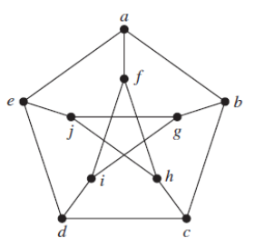 | L5 | CO6 | [7M]
 | b) | Find DFS spanning tree for the following graph  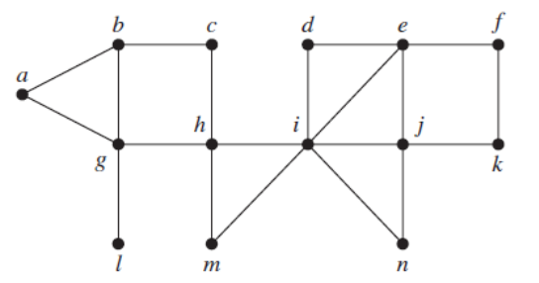 | L3 | CO6 | [7M]
7. | a) | Show that ¬p → (q → r) and q → (p ∨ r) are logically equivalent. | L4 | CO1 | [5M]
 | b) | An insurance company claim to have 920 new policyholders of which 800 bought auto insurance, 420 bought life insurance, 700 bought fire insurance, 350 bought auto and life insurance, 590 bought auto and fire insurance, 300 bought life, fire insurance, and 268 bought auto, life and fire insurance. Explain why the state insurance commission ordered an audit of the company records? | L3 | CO2 | [5M]
 | c) | Determine whether the poset ({1, 5, 25, 125}, ∣) is a lattice? | L3 | CO3 | [4M]
8. | a) | Show that in a group G, for a, b ∈ G, (ab)² = a²b² ⇔ G is abelian. | L4 | CO4 | [5M]
 | b) | Solve the following recurrence relation:  a_{n} = 6a_{n−1} − 8a_{n−2} for n ≥ 2, a₀ = 4, a₁ = 10 | L2 | CO5 | [5M]
 | c) | Find the chromatic number of the following graph:  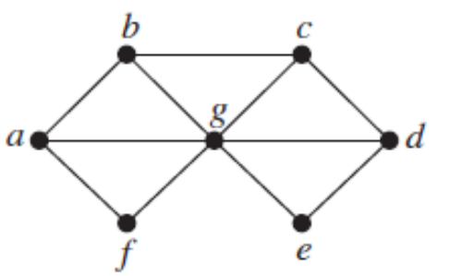 | L2 | CO6 | [4M]

-- 00 -- 00 –

